**FIXED**

**INCOME**

Table of Contents

Reading 50: Fixed-Income Securities: Defining Elements 3

a. Describe basic features of a fixed-income security 3

b. Describe content of a bond indenture 3

c. Compare affirmative and negative covenants and identify examples of each 3

d. Describe how legal, regulatory and tax considerations affect the issuance and trading of fixed income securities 3

# Reading 50: Fixed-Income Securities: Defining Elements

## Describe basic features of a fixed-income security

Key features:

* Issuer of the bond: corporations (financial and nonfinancial companies), sovereign national government, nonsovereign governments (entities that are not the national government like a state or city), quasi-government entities (the ones that are not an obligation of a government) and supernational entities (World Bank, IMF…)
* Bond maturity: the term to maturity or tenor of a bond is the time until maturity. Perpetual bonds have no maturity date so they do not pay the principal. If maturity < 1 year, the bonds are known to be as money market securities. If maturity > 1 year, they are referred as capital market securities.
* Par value” is the principal amount, also known as face, maturity, redemption or principal value. Prices are quoted as a percentage of par. Bonds can be trading at a premium, discount or par.
* Coupon payments: bonds with fixed coupon rates are known as plain vanilla or conventional bonds. Bonds that do not pay any coupon are called zero-coupon or pure discount bonds.
* Currency: dual-currency bonds make interest payments in one currency and the principal payment in another one. Currency option bonds, gives the investor the choice of which of two currencies he wants to receive his payments.

## Describe content of a bond indenture

## Compare affirmative and negative covenants and identify examples of each

Trust deed or bond indenture: legal contract between borrowers and lenders.

The bond indenture includes covenants:

Negative: prohibitions to the borrower. It protects bondholders.

Affirmative: are actions that the borrower must perform, like make its payments.

It also include legal information about the issuer, collaterals, any additional features that increase the probability of repayment (credit enhancements) and, well, covenants.

## Describe how legal, regulatory and tax considerations affect the issuance and trading of fixed income securities

Domestic bonds: issued by a national in local currency.

Foreign bonds: bonds traded on the national market by firms that incorporated I the country but are foreign.

Eurobonds: are issued outside the jurisdiction of any country and denominated in a currency different to the one of the country where they are sold. Eurodollar -> denominated in USD, Euroyen ->denominatend y JPY. They are normally issued in a bearer form (meaning that the evidence of possession simply relies on having the bond, contrary to registered bonds, where a record is kept).

Global bond

**Issuing entities**

Include treasuries of countries or corporations.

Special purpose entities or vehicles: issue securitized bonds and are firms created to purchase financial assets and issue bonds. Are also known as bankruptcy remote vehicles and may issue debt at lower rates due to the fact that the assets it owns assures them they can pay (like other bonds, loans…).

**Sources of repayment**

For sovereign and nonsovereign bonds, the proceeds to pay come from taxes.

Corporation usually use cash from operations.

**Collateral and credit enhancements**

Unsecured bonds: represent a claim over all of the assets and cash flows of the issuer. Are known as debentures except in Great Britain, where the term refers to collateralized bonds.

Secured bonds: represent a claim over specific assets, reducing the risk of default and yield. These assets are the collaterals. They are senior to unsecured bonds; however, unsecured bonds have seniority over subordinated or junior debt. Examples of collateral pledged securities (secured bonds):

* Equipment trust certificates: backed by equipment.
* Collateral trust bonds: backed by financial assets.
* Mortgage-backed security (MBS): the underlying asset is a pool of mortgages which interests and principal repayments are used to repay the MBS interest and principal.
* Covered bonds: are like asset-backed securities but the underlying assets (cover pool) remain on the balance sheet of the issuer (no SPE is creater).

Credit enhancement may be found in the bond structure or provided by a third party.

Internal enhancement involves:

* Overcollateralization (collateral value > pair value of the issue).
* Cash reserve fund, where some cash is set aside to make up for credit losses on the underlying assets
* Excess spread account can also be used, where the yield promised by the issue is lower than the one provided by the asset used as support.
* Issuers use to divide the issue into tranches with different seniority (this generates credit enhancement for higher tranches, offering lower yields but, in contrast the company will have to offer higher yields to the lower tranches), known as waterfall structure.

External credit enhancement includes:

* Surety bonds which are issued by insurances companies that promise to make up any shortfall in the cash available to service debt.
* Bank guarantees -> have the same function.
* Letters of credit are promises to lend money if the issuer does not have enough cash to make payments.

**Taxation of bond income**

Normally, interest paid to holders is taxed as ordinary income (like wages). However, there are exceptions where the income is tax-exempt, like munis.

Whenever a holder sells a bond prior to maturity, it might earn a capital gain which are often taxed at lower rate than regular income.

Original issue discount (OID)” are pure-discount bonds and are only taxable as interest gains (as in some cases no cash payments are done, a tax liability is created).

No me quedaron muy claros los ultimos dos parrafos

## Describe how cash flows of fixed-income securities are structured

Bullet structure: coupon payments are made and the principal is repaid ate the end (making a big payment known as balloon payment).

Amortizing loan: when payments include some interest and some principal.

* Fully amortizing: if all the principal is fully paid off in the intern periods.
* Partially amortizing: here there is a balloon payment but it only include what was left of principal (as some of the principal was equally paid through the periods).

Sinking fund provisions: provide repayments of principal in certain points of the life of the bond (every six years for instance). The disadvantage is that if rates decrease from the first to the sixth year, then the holder would reinvest at a lower rate. I think that the interest will be now calculated over the remaining principal amount.

**Coupon structures:**

* Floating-rate notes (FRN) or floaters:

It uses the market rate as a reference rate plus certain basis points to calculate the interest payment. This type of instruments may count with caps (to protect the issuer) and floors (to protect investors) to stablish minimum and maximum coupon payments.

* Variable-rate notes:

For the case of variable-rate notes, the margin over the market rate is not fixed.

* Inverse floater:

A case where the coupon rate will increase when the reference rate decreases.

* Step-up coupon bonds:

Their structure involves an increase in coupon rate over time according to a schedule, protecting from interest rates rising. They usually are callable at each step-up date, so the firm will call them if the market yield is lower than the call price.

* Credit-linked coupon bond:

Carries a provision that states that the coupon rate will go up by a certain quantity if the issuer’s credit rating falls and go down if the credit rating improves. The thing with this is that a higher coupon rate will be even worse for a company which’s credit rating is downgrading.

* Payment-in-kind (PIK) bond: it consists on paying interest with more bonds (increasing the principal amount). They have normally higher yields as cash is not received.
* Deferred or split coupon bond:

Coupon payments do not begin until a period of time after issuance. Helps companies with projects that require cash but will only generate cash in the future. Zero-coupon bonds can be considered as a deferred coupon bond.

* Index-linked bond:

Are coupons for which their interest payments and/or the value of principal is based on a published index. Inflation bonds (known as linkers) are the most common ones, for which the interest payments are based on the change of the inflation index. Principal protected bonds are index-linked bonds which the principal payment will not be less that the original pair value. Structures of inflation-indexed bonds:

* + - Indexed-annuity bonds: fully amortizing bonds with payments directly adjusted for inflation.
    - Indexed zero-coupon bonds: payment at maturity is adjusted for inflation.
    - Interest-indexed bonds: coupon rate is adjusted for inflation while principal value remains unchanged.
    - Capital-indexed bonds: coupon rate remains constant while the principal value is increased by the rate of inflation (the most common structure, TIPS or UDIBONOS are examples).

When the balance of a bond changes, interest are calculated based on t or t-1?

## Describe contingency provisions affecting the timing and/or nature of cash flows of fixed-income securities and identify whether such provisions benefit the borrower or the lender

Contingency provision: contract that describes the actions to be taken given the occurrence of an event.

Contingency provisions in bond indentures are known as embedded options. Some of these options are exercisable by the issuer and others by the holder. A bond without embedded options are called straight or option-free bonds.

**Callable bonds:**

Gives the issuer the right to redeem all or a part of the issue at a call price. Usually, specific range of dates for calling bonds are determined, variating the call premium (amount over the par value).

The time between the issue and the first callable date is known as the call protection period, lockout period, cushion period or a deferment period.

The first par call date is the first date in which the issue can be called at par.

When currently callable, the call price puts an upper limit on the value of the bond market.

A call option gives value to the issuer, as he can call the issue if the rates go down, and refinance. Also, he could offer a lower rate if his credit rating improves.

However, callable bonds have to offer higher yields (sold at lower prices. Es esto, o mayor cupon?) than noncallable bonds. The difference between two identical callable and noncallable bonds is the value of the call option to the issuer.

Styles of callable bonds:

* American style: can be called any time after the first call date.
* European style: can be called on the specific call date.
* Bermuda style: can be called on specific dates after the first call dat.

Make-whole call provisions: the call price is not fixed but includes a lump-sum payment based on the PV of the future coupons that holder will not receive if the bond is called (which is generally lower than the market value of the bond, making it unlikely to be called). This type of issue compensates the fact that it is a callable bond, so the issuer does not have to offer higher yields. Also, it does not put an upper limit.

**Putable bonds:**

Gives bondholders the right to sell the bond back to the issuer at a put price, typically par. Due to increases in interest rates or in credit risk, holders are likely to exercise the option.

The styles are the same as the ones of the callable bonds.

It is sold at a higher price (lower yield).

**Convertible bonds (also referred as hybrid security):**

Gives bondholders the option to exchange the bond for specific number of shares. The value of the bond will be at least equal to the value of a bond with no conversion option. As they offer value to bondholders, they can be issued at lower yields.

In general, they have the downside protection of a bond and the upside opportunity of equity.

Advantages to issuers include lower yields and the fact that bonds are converted to shares and are not paid.

Important terms:

* Conversion price: price per share (par value always?) at which the bond may be converted to common stock.
* Conversion ratio: par value divided by conversion price.
* Conversion value: market value of the shares that would be received. Market price times conversion ratio.

Conversion value should be above par value so that it is favorable to convert.

Usually this instrument also includes a call provision so that, when the conversion value is higher than the call price, the issuer can call the issue, forcing the holders to exercise their conversion.

**Warrants**

Give holders the right to buy common shares at a given price over a period of time. It makes debt more attractive to investors.

**Contingent convertible bonds**

Known as CoCos, they convert debt to equity automatically if a specific event occurs. They are normally issued by banks so that if their financing structure fall below certain level, the debt is converted to common stock.

# Reading 51: Fixed-Income Markets: Issuance, Trading and Funding

## Describe classifications of global fixed-income markets

Global bond markets can be classified by:

* Type of issuer: government, corporate and securitized bonds (structured finance).
* Credit quality.
* Original maturities: one year or less are money market securities. Greater than a year are capital market securities.
* Coupon structure: floating-rate or fixed-rate bonds.
* Currency denomination.
* Geography: where the bonds were issued, domestic, foreign and Eurobonds. Also by developed and emerging markets.
* Indexing: the index to which the bond refers.
* Tax status: depending of the interest’s taxable status.

## Describe the use of interbank offered rates as reference in floating-rate debt

Interbank rates are based on expected rates for unsecured loans from one bank to another. It is an average excluding the lowest and highest quote.

Usually, the reference rate should have the same term as the coupon payments.

## Describe mechanisms available for issuing bonds in primary markets

Primary market transactions can be sold to the public in a public offer or just to qualified investors in a private placement.

Investment banks help the company with the issuing in the following:

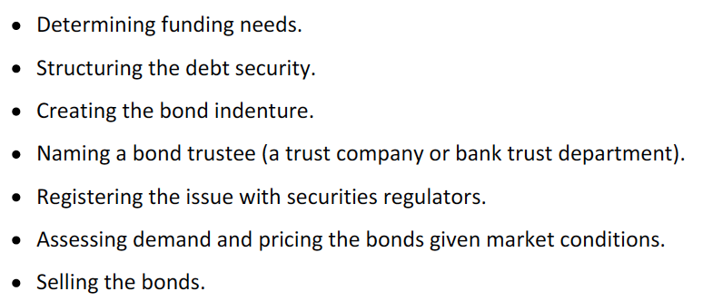

Bonds can be sold through:

* Underwritten offering: the whole issue is purchased by the underwriter (investment bank). Sometimes, more than one bank works as an underwriter, so a syndicate is created. They will then need to sell the issue. When the bonds are traded prior to the offering date, this is known as grey market.
* Best efforts offering: investment banks sell bonds on a commission basis, it does not purchase the whole issue.
* Auction: some bonds are sold through this procedure. Primary dealers make most of the purchase.

Shelf registration.

## Describe secondary markets for bonds

Secondary markets -> trading after issue. Most of the trading is done through dealers or OTC. The spread dealers use is often between 10 and 12 basis points.

Bonds trades are cleared through a clearing system.

## Describe securities issued by sovereign governments

Sovereign bonds are backed by the taxing power of governments. Credit ratings are normally lower when the bond is not issued in local currency.

On-the-run or benchmark bonds are the ones that have been issued more recently. Other yields for other bonds are determined relative to this benchmarks.

## Describe securities issued by non-sovereign governments, quasi-government entities and supranational agencies

Non-sovereign government bonds are issued by states, provencies, counties and by entities created for municipal services. Proceeds form specific project, taxes of special taxes are used to service this type of debt.

Agency or quasi-government bonds are issued by entities created by national governments for specific purpose like financing small business or mortgage financing. Some are backed by the government, others not but still have a high credit quality.

Supranational bonds are issued by multilateral agencies like the World Bank or the IMF. Are usually very liquid and with a high credit quality.

## Describe types of debt issued by corporations

**Bank debt:**

Bilateral and syndicated loans, where the loan is provided by one or by a group of banks respectively. This loans are securitized and traded.

**Commercial paper:**

Are short-term unsecured debt securities that issue large creditworthy corporations (with maturities of 270 days or less, as complying with this criteria enables the company to acoud SEC registration). The rate of interest is lower than the one of a bank loan and are used to fund working capital. It is also a temporary source of funding before issuing longer-term debt (this is known as bridge financing).

Commercial papers is often reissued or rolled over when it matures (the risk of not being able to sell the new issue is known as roll over risk). This risk might arise from a deteriorated financial position or a systematic financial distress, or even an increase in interest rates.

Backup liquidity lines or liquidity enhancement are promises in which the bank provides funds when the paper matures, if needed, except in the case of a material adverse change. This enhance the credit profile and rating of the issuer.

They are usually issue as a pure discount security and prices are quoted as a percentage discount from the face value (discount rate) while ECP rates may be quoted as an add-on yield, which indicates an amount that will be paid extra to the par value.

**Corporate bonds:**

Serial bond issue (alternative to a sinking fund provision) is an issue in which the mature dates are different, so that the company is able to redeem bonds periodically. The investor knows the maturity since the issuing. The antonym of this type of issue is known as a term maturity structure.

They are short term if their maturity is less than 5 years, medium term between 5 and 12 and long term after that.

Medium-term notes (MTNs): their maturity is not necessarily in the medium term. They like this: the issuer gives a range of maturities and provide yield quotes for those ranges, so that investors make an offer to the issuer’s agent, specifying face value and the maturity that they select. Usually financial institutions are both the buyers and issuers of these securities.

## Describe structured financial instruments

Are securities designed to change the risk profile of an underlying debt security, often by combining the security with a derivative. This includes asset-backed securities and collateralized debt obligations.

Other types:

* Yield enhancement instruments (credit-linked note (CLN)): has regular coupon payments but its redemption value depends on an specific credit event. If the even does not occur, the CLN will be redeemed at its par value. Buying a CLN is like using a CDS. Why will the yield of the CLN be higher?
* Capital protected instruments:
* Participation instruments: payments are based on an underlying instrument, refernce interest rate or equity index. A floating rate note is an example, where the bond’s value is relatively stable. Participation based on equity assets is useful for managers that can only invest in debt securities.
* Leveraged instruments: Inverse floater is an example, as there are cases in which the reference rate is multiplied. When this happens, the bond is termed as a leveraged inverse floater. When the multiplier is less than ones, it is known as a deleveraged inverse floater.

## Describe short-term funding alternatives available to banks

Retail deposits, checking accounts and money market funds provide liquidity.

Other examples include:

* Certificates of deposit (CDs): mature on specific dates and offer in short-term. Non-negotiable CDs cannot be sold and withdrawl of funds might imply a penalty. Negotialbe CDs can be sold.
* Central bank funds market: Banks need to have certain deposits in the central bank. Whenever a bank has an excess of this deposits, it might lend it to other banks at the central bank fund rate.
* Interbank funds: different to the ones that come from reserves that are deposited in the central banks. Loans are unsecured.

## Describe repurchase agreements (repos) and the risk associated with them

Arrangement through which one party sells a security to a counterparty with the commitment to buy it back at a higher price (repurchase price) in the future (repo date). This is actually a loan where the original owner is lending funds using the asset as a collateral and gaining interest from the price difference (repo rate, annualized percentage difference and is usually lower than the rate charged by banks).

The percentage difference between the market value and the amount loaned is the repo margin or haircut.

No entiendo por que al precio en que se le vende el activo al comprador es menor que el del mercado

Overnight -> one day operations.

Term repos -> take more than one day.

The repo rate is:

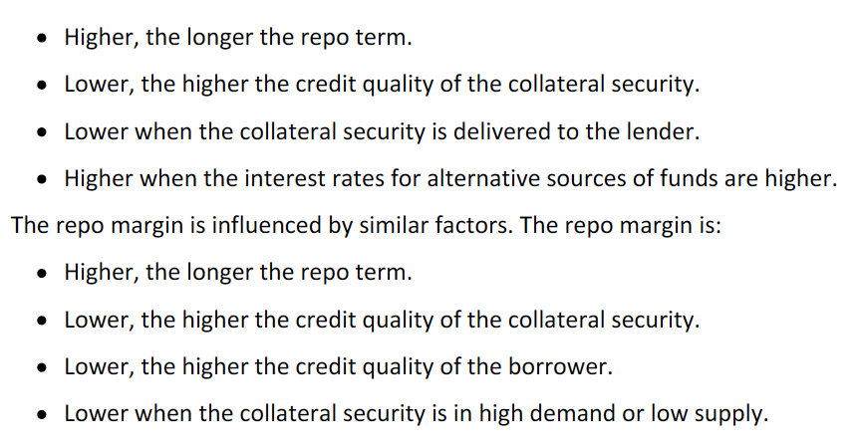

Reverse repo agreement: lending funds by buying the collateral rather than borrowing by selling it.

# Reading 52: Introduction to Fixed-Income Valuation

## Calculate a bond’s price given a market discount rate

The appropriate discount rate of the bond is the YTM or redemption yield (es la de Mercado?).

When the discount rate = coupon rate, the price is the par value, if the discount rate is greater than the coupon rate is under par and lower will be over par.

The relation between the discount rate and the price is convex, as a change of 2 percentage pints of the interest rate will not generate a 2% change.

## Identify the relationships among a bond’s price, coupon rate, maturity and market discount rate (YTM)

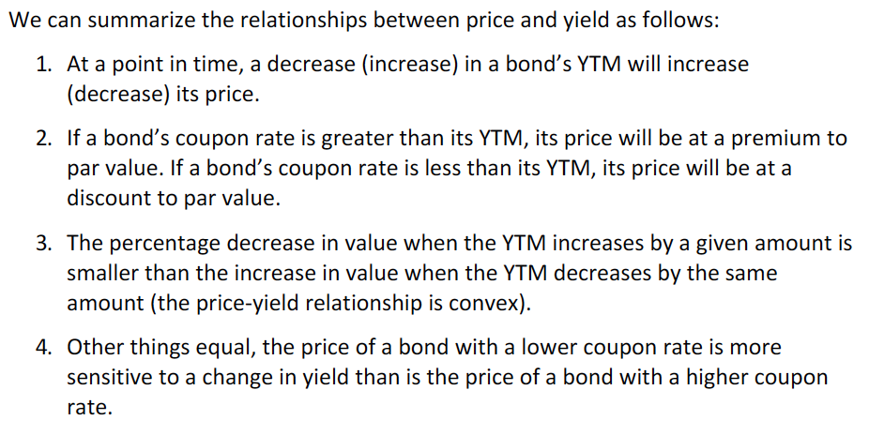



Convex relationship:

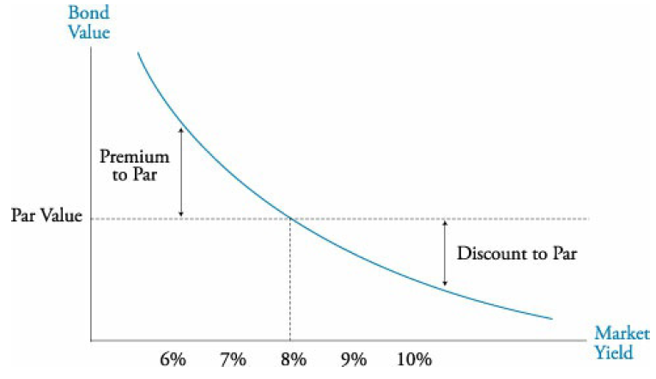

**Relationship between Price and maturity**

When getting close to the mature date, the Price will converge towards par value. This is known as the constant-yield price trajectory.

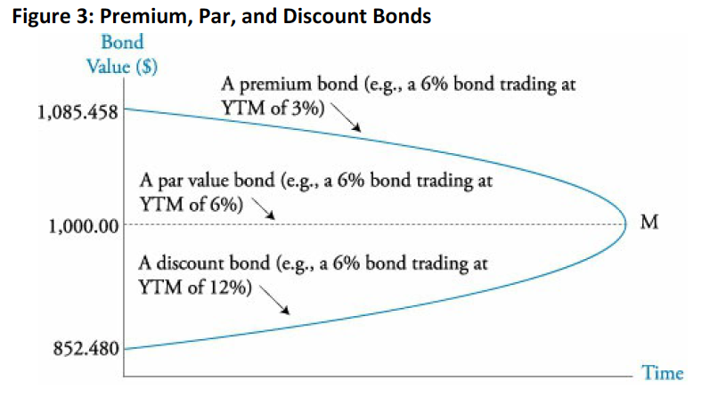

## Define spot rates and calculate the price of a bond using spot rates

Spot rates are the market discount rates for a single payment to be received in the future. They are used for zero-coupon bonds.

When spot rates are used, each cash flow is brought to present value using different rates.



The price calculated using these rates is known as the no-arbitrage price.

So what is correct, using spot rates or using one interest rate to discount? Where is the YTM found?

## Describe and calculate glat price, accrued interest and the full price of a bond

When getting closer to coupon payment dates, the value of the bond increases.

Full price (dirty price): calculated based on the price when the last coupon was payed and then, multiplied by (1+YTM/Coupons per year)^(days since the last coupon payment/ number of days in the coupon period).

Accrued interest can be calculated as the coupon amount times the portion of days that have passed since the last coupon payment over the total days of the coupon period.

Flat price (clean price): is the full price minus the accrued interest. SO IT IS NOT THE PRESENT VALUE ON THE LAST COUPON PAYMENT DATE.

Actual/actual -> used for government bonds.

30/360 -> used for corporate bonds.

## Describe matrix pricing

Is a method used to estimate the required YTM or price of a bond that is not traded. The method consists in using bonds with similar characteristics to estimate the yield.

If there is no bond traded with the same maturity, a simple average between the YTMs of two bonds that mature one year after and one year before than the studied bond.

If the rates are not consecutive in maturity: No entiendo

## Calculate and interpret yield measures for fixed-rate bonds, floating-rate notes and money market instruments

**Yield measures for fixed-rate bonds**

Effective yield: is simply the compounded return (no sería entonces la YTM?).

Periodicity: how frequently coupons are paid.

A YTM of 8% for a semiannual-pay bond will have an effective yield of 8.16% (1.04^2).

Semiannual bond basis: two times the semiannual discount rate. It is how rates are normally quoted.

Street convention yield: calculated based on the payment dates stated (without mattering if it falls on a weekend).

True yield: it considers the dates in which the payments can actually be made.

When comparing government bond yields (actual/actual) with corporate bonds (30/360), yields should be converted to the same basis in order to make sense.

Current yield: it does not consider capital gains or losses or reinvestment income:



Simple yield:

Yield-to-call: it is the yield calculated for each possible call date and price, the lowest yield is known as the yield-to-worst. To calculate the yield-to-call simply calculate the IRR. However, the FV needs to be the call price of the bond, not the face value.

Option-adjusted yield: is calculated by adding the value of the call option (which is the value of a non-callable bond minus the value of the callable bond) to the current flat price. This yield will be less than the YTM.

**Floating-rate note yields**

The values of these assets are more stable than those of fixed-rate because coupon rates are reset periodically (based on a reference rate). Every period the rate is updated so that, at the end of the period, the payments are made with the updated rate.

Quoted margin: margin used to calculate coupon payments.

Required or discount margin: the margin required to return the FRN to its par value. This one is equal to the quoted margin if the credit quality is unchanged and the FRN returns to its par value at each reset date.

If the credit quality decreases, the quoted margin will be less than the required margin and the FRN will sell at a discount.

In a simplified pricing model, all future coupon payments are based on the reference rate on the most recent reset date and discounted using this reference rate and the required margin.

I do not get how the required or discount margin is determined.

**Yields for money market instruments**

US Treasury bills are quoted as annualized discounts based on a 360-day year while Libor and bank CD rates are quoted as add-on yields.

They are quoted as simple annual interest.

Bond equivalent yield: an add-on yield based on a 365-day year.

Review exercise 3-> pa pasar de una tasa annual estipulada capitalizada x periodos a una capitalizable y periodos, la vuelvo efectiva para x, luego annual efectiva, luego efectiva a y periods y luego anual estipulada capitalizable y periodos?

## Define and compare the spot curve, yield curve on coupon bonds, par curve and forward curve

In general terms, a yield curve shows yields by maturity.

Term structure of interest rates refers to yields at different maturity for like securities or interest rates. I do not get the difference, isn’t it the same?

Spot rate yield curve: shows the spot rates, which are the appropriate yields and discount rates for single payments to be made in the future (used when I calculate the price of a bond using different interest rates, depending of the maturity of the payment). The spot curve for US Treasury bonds is known as zero curve or strip curve.

Semiannual bond basis -> refers to a stated annual rate compounded two times a year.

Yield curve on coupon bonds: Show the YTM (an annually stated rate compounded the times the coupon is payed) for different maturities.

Par bond yield cure or par curve: is constructed from the spot curves and the yields reflect the coupon rate that a bond will need to have at each maturity to be priced at par. It is then the YTM of a par bond at each maturity.

To calculate it, simply calculate the coupon rate that, given the spot rates for each maturity, will be equal to the price:

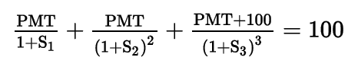

Forward rates: are yields for future periods. For instance, the rate of interest on a 1-year loan that would be made two years from now.

Forward yield curve: show the future rates for bonds or money market securities for the same maturities for annual periods in the future. So the x axis will be the time from now in which the security will have 1-year yield of y?

## Define forward rates and calculate spot rates from forward rates, forward rates from spot rates and the price of a bond using forward rates

Notation: 2y1y refers to a rate for a 1-year loan to be made in two years from now.

**Forward and spot rates relationship**

Borrowing for three years at the 3-year spot rate should be the same as borrowing for one-year periods in three successive years:

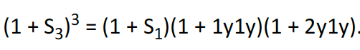

Which is the same as to say that S3 is the geometric mean of S1, 1y1y and 2y1y.

A simple average is also a good guess, although, not the best one.

**Forward rates given spots rates**

The same relationship can be used to calculate forward rates. It simply consists on remembering that it is the same to invest at a spot rate form more than one period as it is to make multiple reinvest in each period at the forward rate.

(1+s2)^2 = (1+s1)*(1+1y1y)

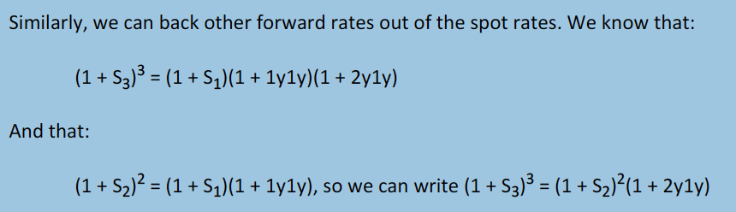

It is simply writing the formula based in the concept and considering the information that is available.

I can check that my calculations are ok by simply calculating the geometric average (which, for the first year, considers the S1 rate).

Both spot and forward rates can be inaccurately estimated using simple average and for fwd rates, simply subtracting the spots rates (getting the 1y1y, simply S2-S1).

**Valuing a bond using forward rates**

When using forward rates, simply consider that the denominator will include a multiplication of the s1 times each year’s forward rate. Different from using spot rates where, for instance for period 3, the denominator considered S3 to the power of three.

## Compare, calculate and interpret yield spread measures

Yield spread -> difference between yields of two different bonds and are quoted in basis points.

Benchmark spread -> yield spread relative to a benchmark.

G-spread -> yield spread over a government bond.

Normally, bonds are benchmarked with other bonds with the same maturity.

For a 5-year corporate bond, when issued, the benchmark spread is stated

relative to a 5-year government bond yield, but two years later (when it has three

years remaining to maturity) its benchmark spread will be stated relative to a 3-year

government bond yield.

Interpolated speads or I- spreads -> yield relative to swaps rates in the same currency.

Professor’s note 82.

Effects directly on the spread are caused by microeconomic factors while the ones generated over the benchmark come from macroeconomic factors.

**Zero-volatility and option-adjusted spreads**

Zero-volatility or Z-spreads are calculated by taking the market price and discounting it by every spot rate of the benchmark plus the spread and solving the formula for the spread.

In the example, when solving for the YTM of the bond, does it fit the mrket price?

Option-adjusted spread (OAS) is used for bonds with embedded options. The OAS is the spread to the government spot rate that the bond would have if it were option-free.

Option value = Z-spread – OAS

OAS = Z-spread - option value

Why will the OAS be less than the Z-spread.

# Reading 53: Introduction to Asset-Backed Securities

## Explain benefits of securitization for economies and financial markets

Securitization refers to the process by which financial assets are purchased by an entity and the issued securities supported by the cash flows from those assets.

Benefits include reductions in funding costs from the firms that sell the assets to the securitizing entity and an increase in the liquidity of the underlying asset.

Also:

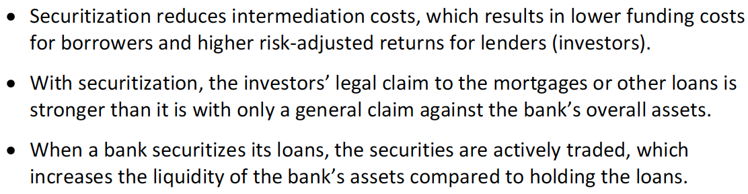

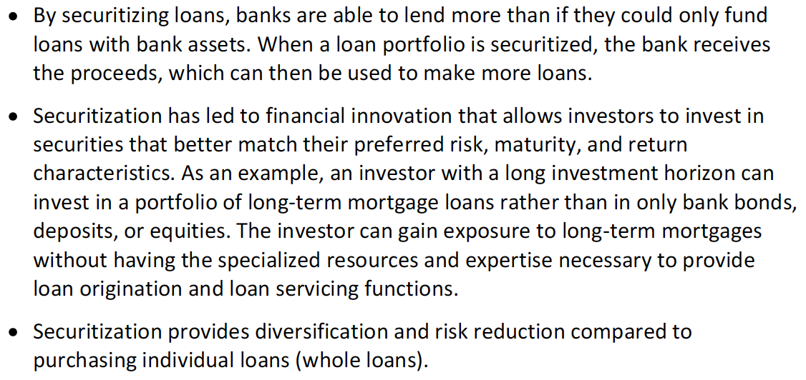

## Describe securitization, including the parties involved in the process and the roles they play

Servicer -> the one that manages the loan by collecting payment, sending notices…)

Trust or the issuer - > Special purpose entity (SPE) or Special purpose vehicle (SPV)-> buys the assets and sell asset backed securities. SPEs are referred to as the. It then sells the ABS to investors, having the loans as collaterals as their cash flows are used to pay to investors.

Seller -> entity that sells the asset (loan).

The transaction goes like this:

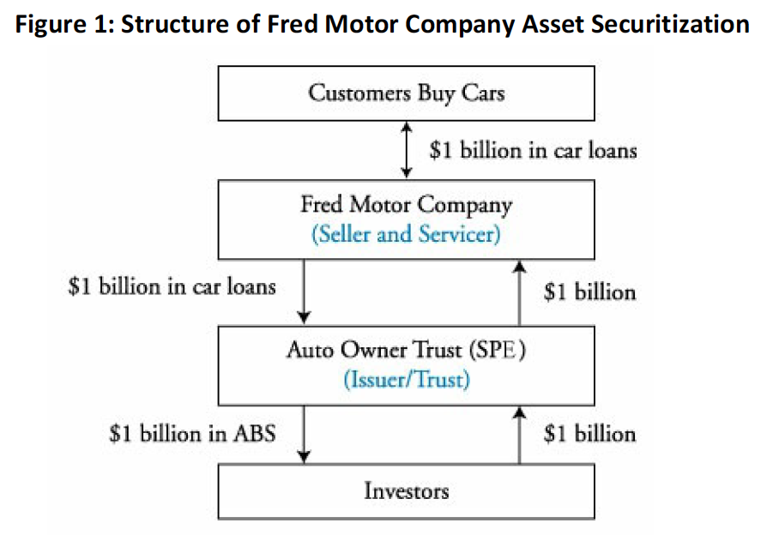

The process could be resume like this:

* Company issues a loan.
* The loan is sold to a SPE.
* The SPE issues ABS.
* Investors buy it.
* With the proceeds of the loans, the ABS interests are served.

Usually, ABS are issued in several classes or tranches, generating waterfall structure of payment.

ABS are usually backed by:

* Automobile loans.
* Credit card receivables.
* Home equity loans.
* Manufactured housing loans.
* Studen loans.
* Small business administration loans.
* Corporate loans.
* Corporate bonds.
* Emerging market bonds.
* Structured financial products.

When the ABS is supported by mortgage, it is known as a mortgage-backed security (MBS).

As the SPE is a separate entity from the seller, investor cannot claim for assets of the seller in the case of default of payments. Then, credit ratings of the ABS do not depend of the seller but of the SPE or issuer, making it attractive.

## Describe typical structures of securitization, including credit tranching and time tranching

ABSs can involve a single or multiple classes. Each class is known as a tranche. Then, the risk of the ABS is redistributed across the tranches (however, the total risk of the issue is the same).

Credit tranching -> different exposures to the risk of default. Also known as senior/subordinated structure (subordinated tranches absorb credit losses as they occur up to their principal values. Here, the concept of waterfall structure is also applied.

First-loss tranche -> the first tranche to absorb losses.

Time tranching -> first tranche receives all principal repayments form the underlying assets up to the principal value of the tranche. The second the same, the third, fourth… until each tranche’s principal is repaid (considering availability of cash, clearly).

## Describe types and characteristics of residential mortgage loans that are typically securitized

Residential mortgage loan: a loan which its collateral is a residential real estate.

Loan-to-value ratio (LTV): loan / value of collateral. The lower LTV, the higher the borrower’s equity in the property and, therefore, less risk.

Prime loans: high LTV and borrowers with good credit.

Subprime loans: the opposite.

Mortgages characteristics:

**Maturity**

In the US they go from 15 to 30 years, in Europe 20 to 50 and in Japan even up to 100 years.

**Interest rate**

Fixed-rate mortgages have a fixed rate over the life of the loan.

Variable-rate mortgages or adjustable-rate mortgages (ARM) have interest rates that change over time. Index-referenced mortgages change their rate based on a reference rate (if it is not this way, how else does the rate varies?).

There are also hybrid mortgages, where the loan begins at a fixed-rate and then becomes and ARM.

Whenever the change is to other fixed rates, it is called rollover or renegotiable mortgage.

Convertible mortgages involve an option that the borrower can call if he wants to change from a fixed (adjusted) to an adjustable (fixed) rate.

**Amortization of principal**

Fully amortizing loan include both interest and principal repayment. So after the last payment, there is no principal remaining. When payments are fixed, at the beginning they have a large component of interest and then a large component of principal.

Partially amortizing loans involve a balloon payment at maturity as payments of principal are lower through the life of the loan.

Interest-only mortgage refer to mortgages in which only interest is paid during an initial period or the whole life of the loan (interest-only lifetime mortgage). The first type may be fully amortizing or partially amortizing after the initial period while the second type involves a balloon payment equal to the original principal.

**Repayment provisions**

Prepayment: when a partial or full repayment in excess to the schedule repayment in done. This action is commonly made when the house is sold by the homeowner. Also when the loan is refinanced and simply because the borrower wants to reduce the principal outstanding to reduce interest charge and even pay off the whole loan prior to maturity.

Prepayment penalty: a penalty that triggers if prepayments are done that works either for an initial period or for the life-time of the loan.

**Foreclosure**

Non-recourse loans: lender has no claim against the assets of the borrower except for the collateral property itself. Sometimes, for these cases, borrowers voluntarily return the property to the lender (strategic default) when the market value of the property is lower than the loan’s principal repayment.

Recourse loans: lender has claim against the borrower assets (including the property) for the principal amount.

## Describe types and characteristics of residential mortgage-backed securities, including mortgages pass-through securities and collateralized mortgage obligations and explain the cash flows and risks for each type

## Define prepayment risk and describe the prepayment risk of mortgage backed securities

Residential mortgage-backed securities (RMBS) can be:

* Non-agency RMBS.
* Agency RMBS: are issued by the government (Ginnie Mae or Fannie Mae or Freddie Mac, the first one is backed by the national government while the other two are backed by the Federal government).

Agency RMBS are mortgage passthrough securities, meaning that they represent claims on the cash flows from a pool of securitized mortgages. From the pool, the weighted average maturity (WAM) and the weighted average coupon (WAC) is calculated, weighting the mortgages by their principal balances.

Conforming loans are the ones accepted into the pool of mortgages by meeting certain characteristics (% of down payment, a maximum LTV, maximum size, minimum documentation required, and insurance purchased by the borrower). Non-conforming loans are the ones that are not meet the criteria (they can go to a pool of non-agency RMBS).

Fees: they are charged because the pass-through rates (the coupon rate of the MBS) is less than the mortgage rate of the underlying mortgages in the pool.

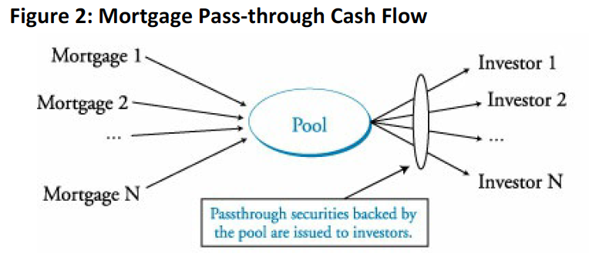

**Prepayment risk**

Is the risk that the issuer of securities has due to the fact that mortgages may be repaid. In fact, for agency RMBS, the loans have no prepayment penalty.

Extension risk: prepayments are slower than expected, making the average life of the investment higher. Low PSA.

Contraction risk: prepayments are faster than expected, making the average life of the investment lower. High PSA.

Due to the existence of prepayment risk (making cash flows uncertain), some assumptions are made about prepayment rates when valuing mortgage pass-through securities. This rates are the single monthly mortality rate (SMM, percentage by which repayments reduce the month-end principal balance compared to what it would have been if no repayments were done) and the conditional prepayment rate (CPR, an annualized measure of prepayments).

Public Securities Association (PSA) prepayment benchmark: is a benchmark used to compare the CPR of the MBS. If the CPR of the MBS equals the one of the PSA prepayment benchmark, then it is said that it is PSA 100 (100%). When prepayments are only 50% relative to the ones of the PSA benchmark, it is said that it is a PSA 50.

Weighted or simple average of life (which is less than the WAM because it considers prepayments) can be calculated using the prepayment rate of the MBS.

**Collateralized mortgage obligation (CMOs)**

Are securities collateralized by RMBS. CMOs use tranches, redistributing risks like prepayment risk. Because some investors are concerned for extension (Do not get why) and others for contraction risk, CMOs offer an alternative that meets investors’ preferences.

The main structures include sequential pay tranches, planned amortization tranches (PACs), support tranches and floating-rate tranches.

**Sequential pay CMO**

Under this structure, every tranche receives interest payments (considering the principal balance of the tranche and the interest rate) but, for principal payments, the second tranche will not receive any payment until the first tranche’s (short tranche) principal is fully paid. Then it happens the same for the following tranches.

Example: The first picture shows the distribution of cash flows on the first period and of a period in the future.

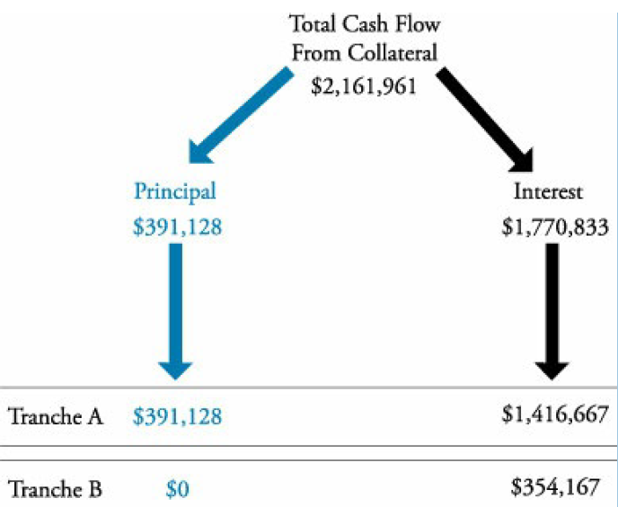

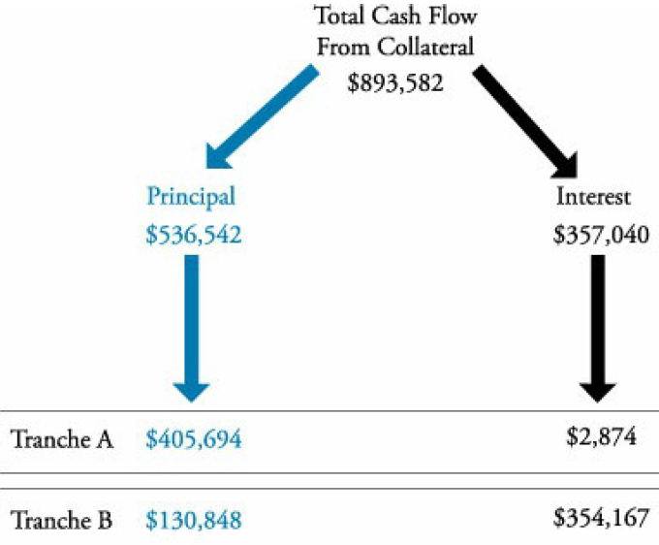

The first tranche will then have more protection against extension risk and the second against contraction risk.

**Planned amortization class (PAC) CMO**

This structure may be composed by one or more PAC tranches and support tranches. The PAC tranches are structured to receive fixed payments regardless the actual payments of the underlying pool of MBS, reducing both contraction and extension risk.

In order to achieve this structure, the prepayment risk of the support tranches is increased. If principal repayments are done faster, the support tranche will receive the excess of repayments and if the repayment rate is lower, the principal repayment of the support tranche will be lower to compensate the one of the PAC tranches. The larger the proportion of support tranches to PAC tranches, the lower the probability that PAC tranches do not receive their schedule payment.

Support tranches have higher contraction and extension risk than the PAC tranche and the underlying MBS.

Initial PAC collar: the bounds on prepayment rate for which the support tranches are sufficient to support PAC tranches.

Broken PAC: when the bounds are broken and the PAC tranches cannot receive their schedule payments.

*Changes in repayment rates changes the average life of the support tranche (and of the PAC if it gets broken).

**No-Agency RMBS**

They are not guaranteed by the government so it has a higher credit risk (is the one of the borrower).

To be investment grade, they normally include credit enhancement (rating agency determine the amount of enhancement needed to improve credit rating). Tranching is normally used for this.

Shifting interest mechanism

## Describe characteristics and risks of commercial mortgage-backed securities

Commercial mortgage-backed securities (CMBS) are backed by income-producing real estate.

* Apartments
* Warehouese
* Shopping centers
* Office buildings
* Health care facilities
* Senior housing
* Hotel properties

The difference with residential mortgages is that the mortgage is not repaid by a homeowner but by a real estate investor that relies on tenants and customers to provide loan repayments.

CMBS are nonrecourse loans (the lender can only look to the collateral as a means to repay the loan if cash flows from the property are insufficient). Residential mortgages are recourse loans, so the lender can go with the borrower to try and collect what it is remaining after selling the asset (if it is not enough).

So CMBS focuses its credit risk on the credit risk of the property and no the borrower. Two main measures are used:

* Debt-to-service-coverage-ratio (DSC) (based on the property):

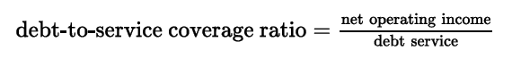

The net operating income is net of real estate taxes but before income taxes.

* Loan-to-value ratio:



For CMBS tranches are also used.

Call protection: there are two ways -> loan-level call protection provided by the terms of the individual mortgages and call protection provided by the CMBS structure.

* Means for loan-level call protection: prepayment lockout, defeasance, prepayment penalty points, yield maintenance charges.

No entendí de call protection en Adelante.

## Describe types and characteristics of non-mortgage asset-backed securities, including the cash flows and risks of each type

They are ABS backed by other type of financial assets: small business loans, accounts receivable, credit card receivables, automobile loans, home equity loans and manufactured housing loans.

**Auto loan ABS**

Loans have maturities of 36-72 months. The cash flow is composed by interest payments, principal payment and prepayments.

Loans are prepaid if cars are sold, traded in or repossessed or stolen or wrecked (the last two come from insurance proceeds).

Almost all present some sort of credit enhancement like senior-subordinated structure, reserve accounts, excess interest spread or overcollateralization.

**Credit card ABS**

Cash flows include finance charges, annual fees and principal repayments. Since they are revolving (non-amortizing), the principal is maintained.

Interest is paid periodically but principal is not during a lockout period (1.5 – 10 years).

If a credit card holder makes prepayments, these proceed are used to purchase additional credit card receivables to keep the value of the pool constant.

No entiendo cómo se hace el pago de principal.

## Describe collateralized debt obligations, including their cash flows and risks

CDO -> structured security issued by an SPE for which the collateral is a pool of debt obligations.

CBO (collateralizd bond obligations) -> are backed by corporate and emerging market debt.

CLO (collateralized loan obligations) -> are backed by a portfolio of leveraged bank loans.

CDOs do not rely on interest payments like ABS. Instead, there is a collateral manager who buys and sells securities in the collateral pool to generate cash and make the promised payments.

Structured finance CDO -> where the collateral is ABS, RMBS, other CDOs and CMBS.

Synthetic CDO -> where the collateral is a portfolio of CDS on structured securities.

CDOs also use bond classes (tranches): senior, mezzanine and subordinated.

Arbitrage CDO -> profit from the spread between funding costs and portfolio returns.

Entonces el CDO es como un protafolio de deuda?

# Reading 54: Understanding Fixed-Income Risk and Return

## Calculate and interpret the sources of return from investing in a fixed-rate bond

Three sources:

* Coupon and principal payments.
* Interest earned on coupon payments that are reinvested. ESTO NO LO ASUME EL MODELO DE VALUACION DE BONOS NORMAL?
* Any capital gain or loss if the bond is sold prior to maturity.

It is assumed that every payment is done on time and that the interest gain on the reinvestment of the coupons is the same as the YTM.

Annualized holding period rate of return -> compounded annual return earned from the bond.

Results:

1. If an investor holds the bond to maturity, his rate of return will be equal to the YTM when purchased.

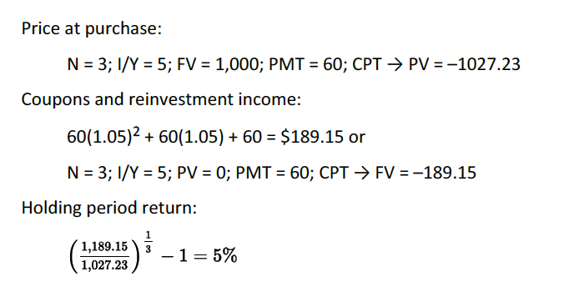

1. If an investor sells a bond prior to maturity, he will earn an annualized rate equal to the YTM at purchase if the YTM at sale is the same.

Carrying value: value of the bond between purchase and sale dates using the purchase YTM.

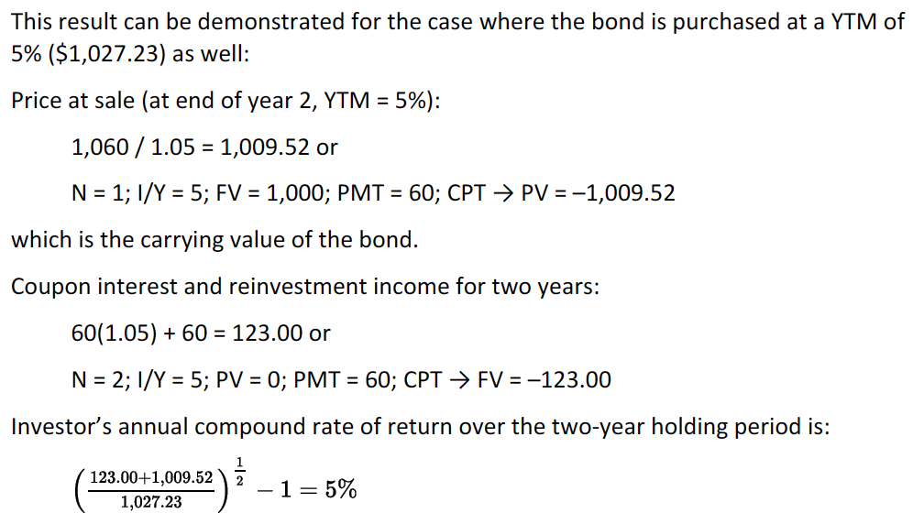

1. If rates rise before the first coupon date, an investor who holds a bond to maturity will earn a rate of return greater than the YTM at purchase (this considering that interest is reinvested).

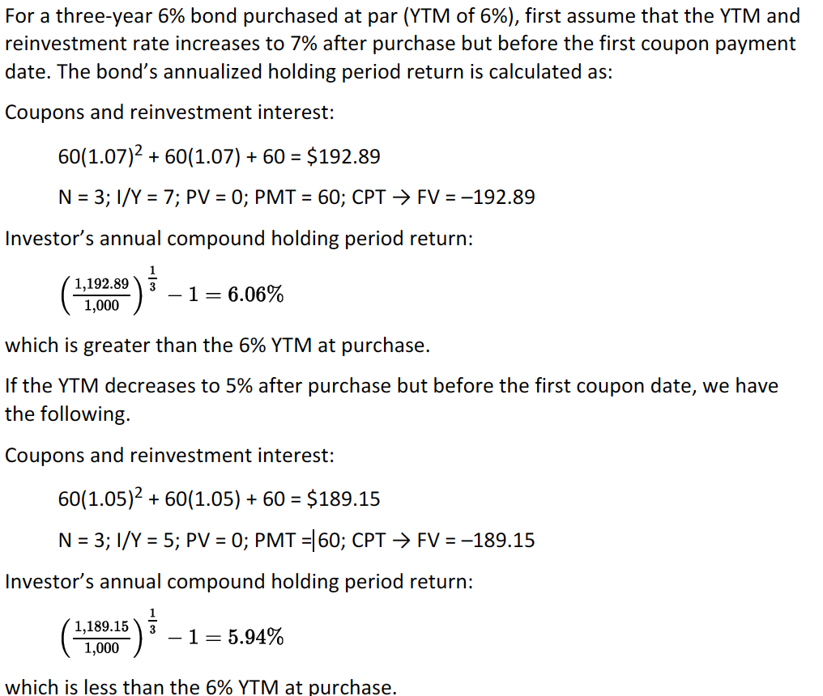

The investor’s rate of return will fall between the original and the new YTM.

1. If the YTM increases after the bond is purchased but before the first coupon date the rate of return earned will be lower than the YTM at bond purchase if the bond is held for a short period.

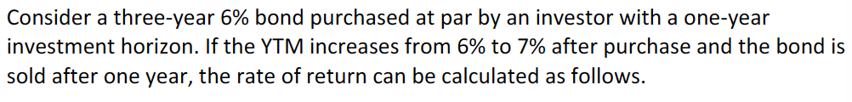

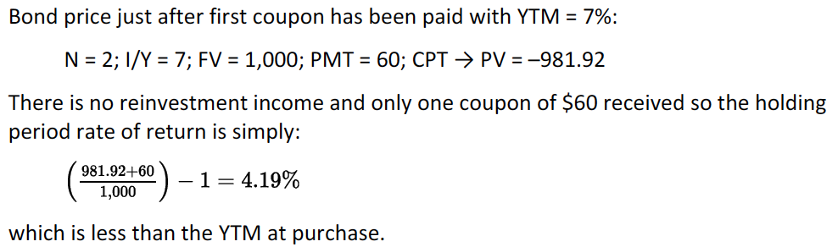

1. If the YTM decreases after the bond is purchased but before the first coupon date the rate of return earned will be lower than the YTM at bond purchase if the bond is held for a long period.

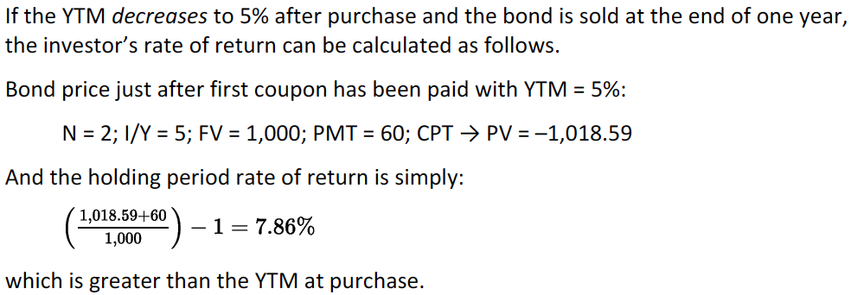

NO ENTIENDO LA DIFERENCIA ENTRE EL 4 Y EL 5, PUES SUPUESTAMENTE CAMBIA EL HORIZONTE PERO PUES LO VEO IGUAL

These results come from the idea of a trade-off between market risk and reinvestment risk.

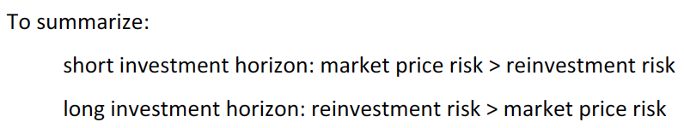

## Define, calculate and interpret Macaulay, modified and effective durations

**Macaulay Duration**

Duration measures the sensitivity of a bond’s full price to a change in its yield. It is ithe weighted average of the number of years until each cash flows are paid, where the weights are the present value of each cash flow.

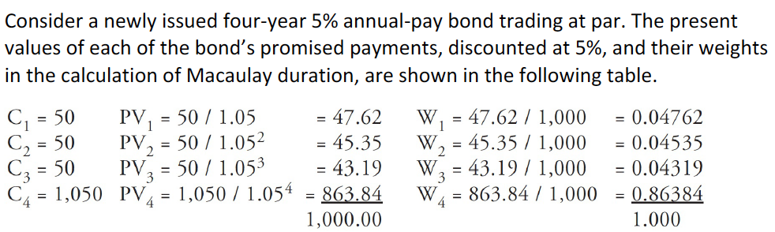



**Modified Duration**

Is the Macaulay duration divided by one plus the bond’s yield to maturity. It provides an approximate change in the bond’s price for a 1% change in the YTM.



**Approximate modified duration**

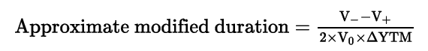

Where V_ is the price of the bond if YTM is decreased by the change of the YTM and V+ is the price if the YTM is increased by the change of YTM. V0 is the current price of the bond. Is basically a percentage change of an average of the magnitudes of the price increase and decrease from the original price.

The result is interpreted as how a change in 1% of the YTM affects the price.

It provides a good estimation for small changes but a poor one to big changes in yield.

**Effective Duration**

There is an issue with the previous calculations since there are callable bonds and mortgage-backed bonds (due to prepayment options) which conclude in uncertain cash flows.

The calculation is the same as the previous duration but, the difference relies in that the change in the YTM is replaced by the change in the benchmark yield curve.

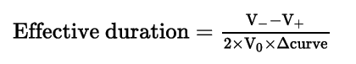

By using the changes in the curve, the credit risk is not measured since the spread is not considered in the calculation. It might be more effective for bigger changes.

## Explain why effective duration is the most appropriate measure of interest rate risk for bonds with embedded options

## Define key rate duration and describe the use of key rate durations in measuring the sensitivity of bonds to changes in the shape of the benchmark yield curve

Measures the impact of nonparallel shifts of the yield curve to the price. Is also known as partial duration and it is the sensitivity to changes in the spot rate for a specific maturity leaving other spot rates constant.

It can be calculated for each maturity and then summed to find the effect of the overall portfolio.

## Explain how a bond’s maturity, coupon and yield level affect its interest rate risk

An increase in maturity increases risk, since future payments are more sensitive to changes in the discount rate. For discount bonds, maturity first increases duration and then decreases it (until perpetuity).

An increase in coupon rate will decrease interest rate risk. The duration of a coupon zero bond is greater than that of a coupon bond. This happens because increasing coupon rate implies that bigger cash flows will be received sooner, decreasing then its duration.

Increases in YTM decreases interest rate risk. By simply looking at a yield curve, at lower YTM, the curve is steeper, meaning that the price will be more sensitive to a change in YTM.

Adding a put or call provision will decrease the interest risk as measured by the effective duration.

## Calculate the duration of a portfolio and explain the limitation of portfolio duration

There are two approaches: calculate the weighted average number of periods of all of the cash flows or, to take the weighted average of the durations of individual bonds.

The first one is not that used since a cash flow yield (the IRR of the portfolio) is used rather than the YTM.

The second is the most used. The weights are estimated using the whole prices of the bonds:

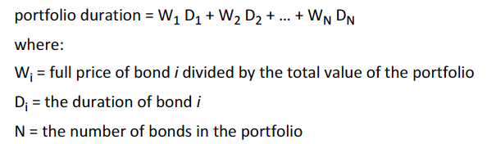

The issue that arise from looking at a duration of the portfolio is that it needs to be assumed that the YTM of every bond changes by the same amount (parallel shift of the yield curve).

## Calculate and interpret the money duration of a bond and price value of a basis point (PVBP)